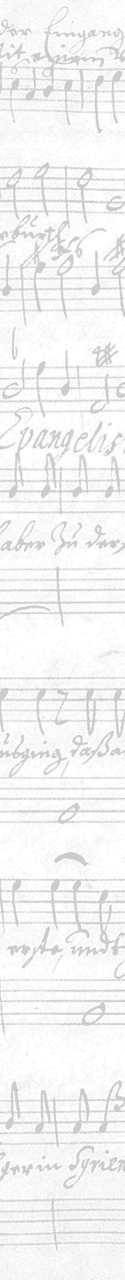


Ruth Boyd,
Chair,
Saint George’s Singers,

Musical Director of St George’s Singers
Role Description

St George’s Singers is a SATB adult choir of approximately 40 singers, based at St George’s Church, High Street, Belfast. The choir was established in 1984 with a view to performing the choral work of the baroque period, although the repertoire has developed to include music from the 16th to 21st Centuries.

We are a diverse cross-community group who share a love of singing and of performing to the highest standard that we can achieve. Our season starts in September and runs through to May / June with the main focus of a Christmas concert, held in St George’s Church and a Spring Concert held in a concert venue or church often in Belfast but sometimes elsewhere in Ireland.

Formed as an Association under its Constitution, the choir is managed by a committee elected from the membership who lead on strategic direction, co-ordination of events, general administration and finance; there is also a choir Librarian. The choir rehearses on Monday evenings from 7.45 to 10.00pm with a short refreshment interval.

Marion Doherty Hayden has been the Director of Music since 2009 and has decided to retire at the end of May 2018. We are recruiting now to appoint by June 2018 to allow time for the next season’s programme to be discussed with rehearsals re-commencing September 2018.

The role will be freelance, paid on a fee per rehearsal / concert basis. The role will be appointed for one year in the first instance, subject to renewal on a year by year basis by mutual agreement.

Principal Function

The Director of Music will have the vision to choose a suitable programme of music for the season and to lead the next phase of the choir’s development, to take the weekly rehearsals and to conduct the choir and orchestra at concerts.

Duties

- To take weekly Monday evening rehearsals at St George’s Church, High St Belfast, motivating and encouraging all members of the choir.

- To plan the programme and concert dates for the season, as well as agreeing associated budget, in conjunction with the Chair and committee.

- To book and arrange fees for soloists and orchestral players as required, in conjunction with the Chair and Committee

- To liaise with the committee to organise extra rehearsals with soloists, orchestra and choir in the run up to concerts.

- To participate in choir workshops, training and development sessions and outreach programme.

- To agree goals for increased (balanced voice) membership with Committee.

- To audition potential new choir members.

- To be responsible for maintaining and developing the highest possible standards of performance from the choir.

Personal Qualities and Experience

The choir requires a Musical Director with:

- Extensive experience of choral music and direction with a demonstrable track record in the field.

- Excellent communication skills, good sense of humour and the ability to mix with all the differing types of people in the choir.

- The ability to get the best from a group of singers with varying experience and level but an equal commitment to choral singing.

- An unwavering commitment to the highest standards.

- Ability to accompany the choir at rehearsal.

